Curriculum Vitae

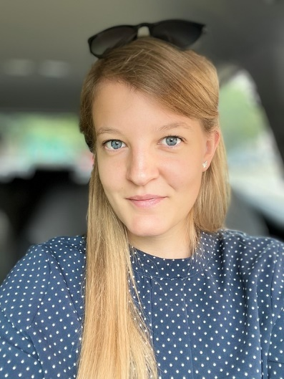
Veronica Pampanin

Contact: E-Mail: vepampan@uni-mainz.de
Tel: 06131 39 26 124

Education:
Since 04/2021 PhD – Neurobiology Ryglewski Lab, iDN
Johannes-Gutenberg-University, Mainz
12/2020 – Master of Science – Biology
04/2018 Johannes-Gutenberg-University, Mainz
Master’s Thesis: Function and Subcellular Localization of Cacophony Splice Variants in Drosophila Motoneurons
04/2018 – Bachelor of Science – Biology
03/2015 Johannes-Gutenberg-University, Mainz
Bachelor’s Thesis: The Role of a Cacophony Isoform for Courtship and Mating Success in Drosophila melanogaster
04/2014 Secondary school – A-levels
Bertha-von-Suttner Gymnasium, Andernach

Conferences:
03/2023 15th Göttingen Meeting of the German Neuroscience Society
Poster: Localization and function of mutually exclusive exons of the Ca_{v}2 channel cacophony in the Drosophila visual system

Scientific Techniques:
Model system Drosophila
Imaging Immunocytochemistry & CLSM Ca²⁺-Imaging
Molecular PCR Western Blotting
Physiology Electromyography of DLM Motoneurons & Electroconvulsive Seizure Assays
Cell Culture Drosophila Motoneuron Primary Cell Culture
Behavior Larval Crawling, Flight

Languages:
German – native Italian – native
English – fluent

